Project Report
Automated Network Request Management
Team ID: Servicenow
Prepared by: Puchakayala Asritha
Date: 06/09/2026
1. Introduction
1.1 Project Overview
Automated Network Request Management is a ServiceNow-based solution that streamlines how employees request network-related services — new or existing connections, bandwidth changes, and related IT infrastructure needs — replacing manual, email-driven handling with a structured, trackable, policy-compliant digital workflow.
1.2 Purpose
The solution aims to reduce manual effort and error, accelerate fulfilment, enforce standardized approvals, improve visibility for requesters and IT teams, and ensure compliance with IT and security policy — all using native ServiceNow capabilities (Service Catalog, Flow Designer, and the Approval engine) with no custom scripting.
2. Ideation Phase
2.1 Problem Statement
PS-1: An employee who needs a new or existing network connection is trying to submit and track a request quickly, but there is no structured system — requests go through emails and phone calls — because network requests are not centralized with defined approval stages, which makes them feel frustrated and uncertain about when the request will be fulfilled.
PS-2: A member of the IT/network fulfilment team is trying to process and approve requests efficiently, but has to manually track approvals and data across emails and spreadsheets, because there is no automated workflow linking intake to approval routing, which leaves them feeling overwhelmed and at risk of errors.
2.2 Empathy Map Canvas
Persona: an employee raising a request for a new or existing network connection. Before automation, they felt the process should be as simple as any other IT request, worried requests would get lost in email threads, and wanted clear confirmation of progress — resulting in repeated follow-up emails and helpdesk calls. The solution addresses this by giving them a single guided form and real-time visibility into approval and fulfilment status.
2.3 Brainstorming
Nine ideas were evaluated against importance and feasibility — spanning custom Service Portal widgets, custom scripting (Business Rules/Script Includes), third-party provisioning integrations, manual email approval, and native ServiceNow configuration. The selected approach combined a Service Catalog item, a dedicated custom table, and Flow Designer automation with the native Approval engine: it scored highest on both importance and feasibility, required no custom scripting, and was the most maintainable option within scope.
3. Requirement Analysis
3.1 Customer Journey Map
The requester's journey spans five stages — Realize Need, Submit Request, Approval & Processing, Fulfilment, and Closure & Feedback. Prior to this solution, requesters had no clear starting point, scattered request details across emails, faced delayed approvals with no visibility, and had to call IT to learn the outcome. The new solution provides a guided submission form, automated routing, and automatic status emails at each stage.
3.2 Solution Requirement
Functional requirements (summary):
FR No. | Requirement (Epic)
FR-1 | Network Request Submission
FR-2 | Requester Auto-Population
FR-3 | Conditional Form Behaviour
FR-4 | Automated Record Creation
FR-5 | Approval Routing
FR-6 | Notifications
FR-7 | Access Control

Non-functional requirements (summary):
NFR No. | Requirement
NFR-1 | Usability — single guided catalog form with conditional fields
NFR-2 | Security — role-based ACLs restrict access to request data
NFR-3 | Reliability — Flow Designer ensures consistent execution for every request
NFR-4 | Performance — submission, record creation, and notifications complete in real time
NFR-5 | Availability — inherits ServiceNow's vendor-managed uptime SLAs
NFR-6 | Scalability — multi-tenant platform supports adding further request types
3.3 Data Flow Diagram
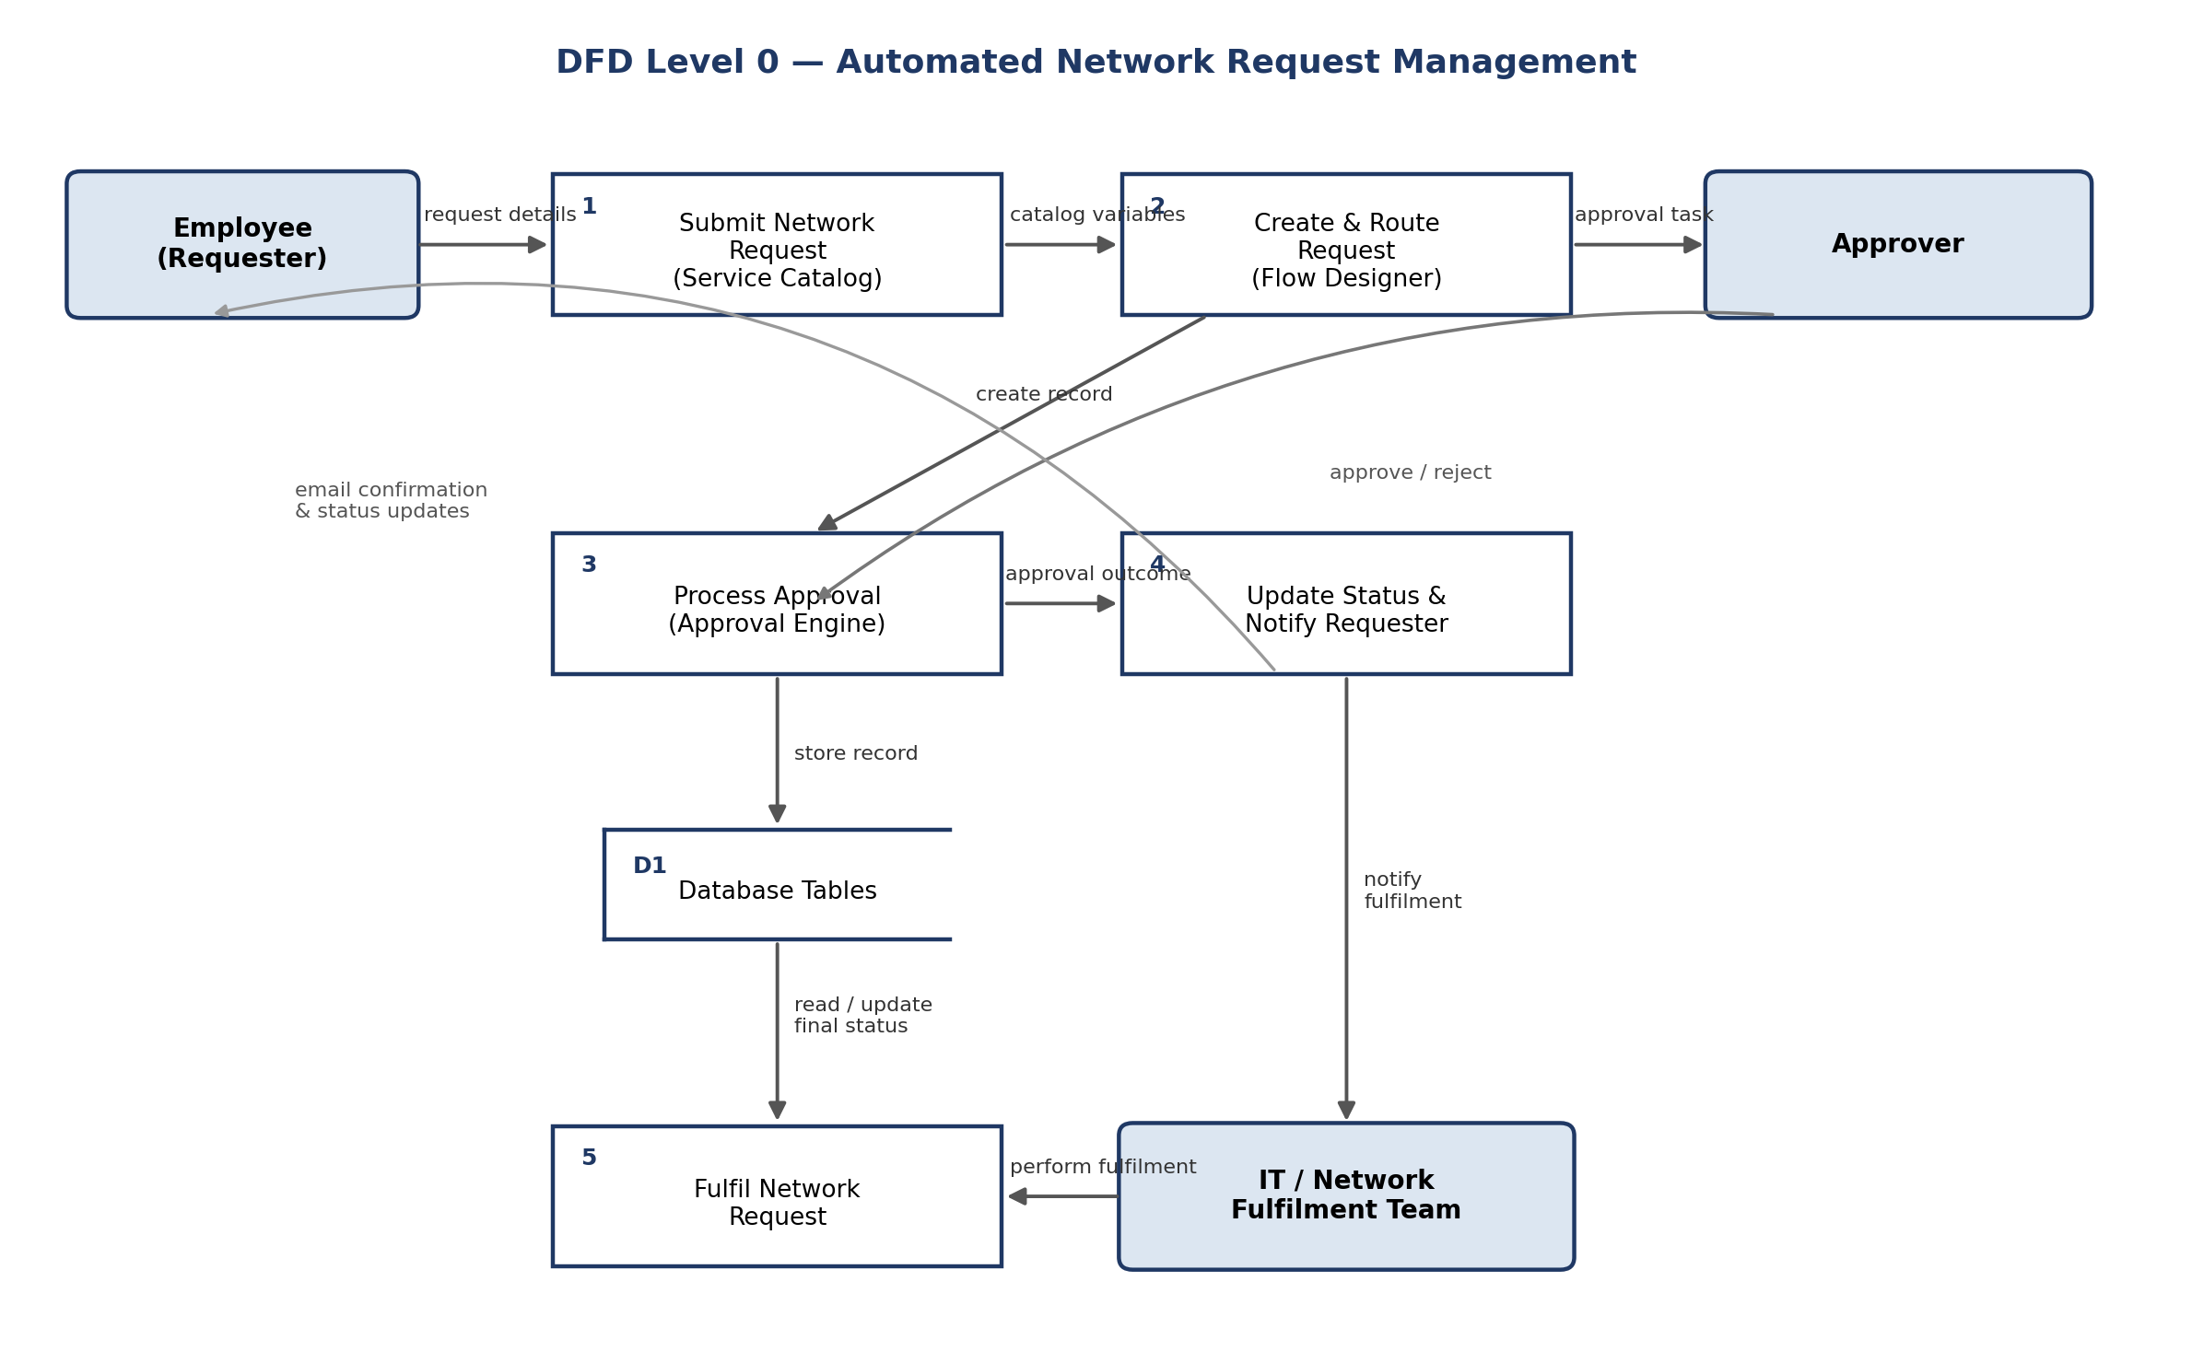
3.4 Technology Stack
Component | Technology
User Interface | ServiceNow Service Portal (Now Experience UI) — Network Request catalog item
Application Logic | Flow Designer — Get Catalog Variables, Create Record, Send Email, Ask for Approval, If/Else
Database | Custom ServiceNow table — Database Tables (u_database_tables)
Infrastructure | ServiceNow Personal Developer Instance (PDI), cloud-hosted
Security | Role-based ACLs scoped to u_database_tables_user
4. Project Design
4.1 Problem Solution Fit
The Problem-Solution Fit canvas mapped customer segments (requesters, managers, IT/network fulfilment), constraints (no dedicated system, limited IT bandwidth, no status visibility), and available prior solutions (emails, calls, generic tickets, manual spreadsheets) against the proposed solution: a Service Catalog item, variable set, Flow Designer automation, and native approvals — directly targeting the triggers (onboarding, relocation, bandwidth needs) and emotional shift from frustration to confidence.
4.2 Proposed Solution
Parameter | Description
Problem Statement | No structured, centralized way to raise or track network service requests
Idea / Solution | ServiceNow Service Catalog + Flow Designer + native Approval engine + custom table
Novelty | Guided intake, conditional UI Policy, and end-to-end no-code automation with no custom scripting
Social Impact | Reduces employee frustration and IT manual effort; increases trust in IT service delivery
Business Model | Internal IT cost-saving — reduced manual effort rather than external revenue
Scalability | Same catalog + flow pattern extensible to other IT service requests
4.3 Solution Architecture
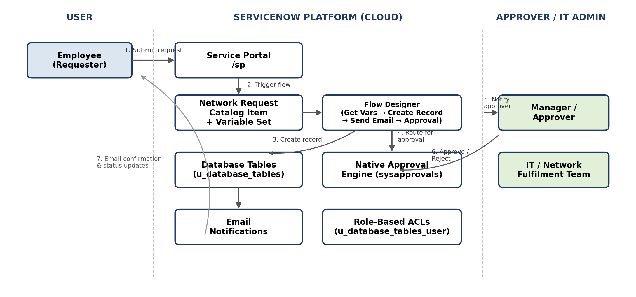
5. Project Planning & Scheduling
5.1 Project Planning
The backlog was organized into 5 epics and 8 user stories (USN-1 to USN-8) delivered across 2 sprints:
Sprint | Total Story Points | Duration | Start (Planned) | End (Planned) | Completed
Sprint-1 | 9 | 6 Days | 03 Aug 2026 | 08 Aug 2026 | 9
Sprint-2 | 13 | 6 Days | 10 Aug 2026 | 15 Aug 2026 | 13

Total story points = 22 across 2 sprints → team velocity = 11.0 story points per sprint. Both sprints tracked close to the ideal burndown line and completed within their planned 6-day duration.
6. Functional and Performance Testing
6.1 Performance Testing
User Acceptance Testing covered 9 detailed test cases (TC-001–TC-009) spanning request submission, conditional UI behaviour, record creation, approval routing, and access control — all passing. Test Case Analysis across 8 functional areas totalled 37 test cases, 100% passing. Defect Analysis logged 17 issues across severity levels during testing; the majority were resolved as Fixed (10) or accepted By Design (3), with 3 bugs tracked individually (2 closed/fixed, 1 Won't Fix as an out-of-scope edge case).
7. Results
7.1 Output Screenshots
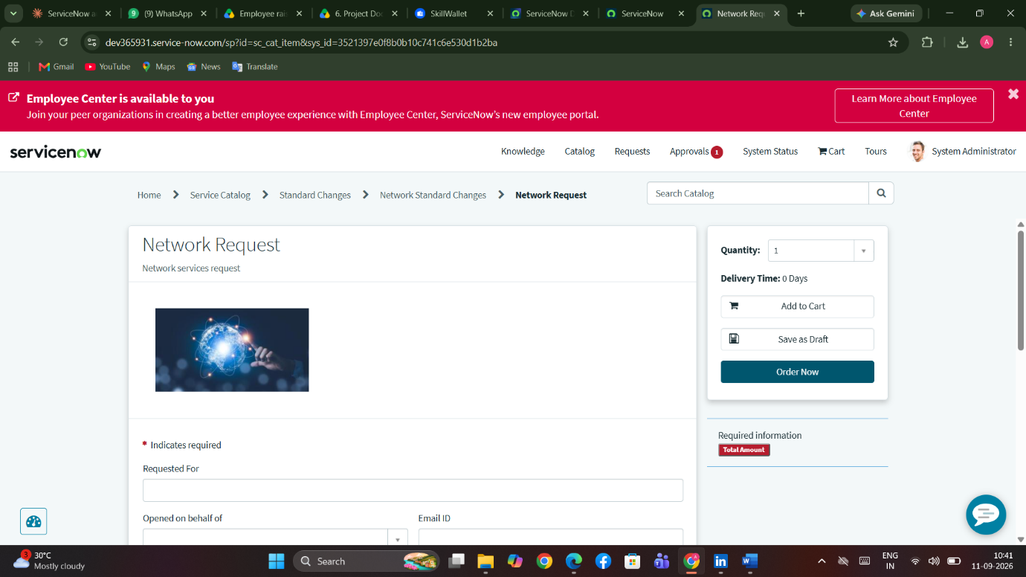
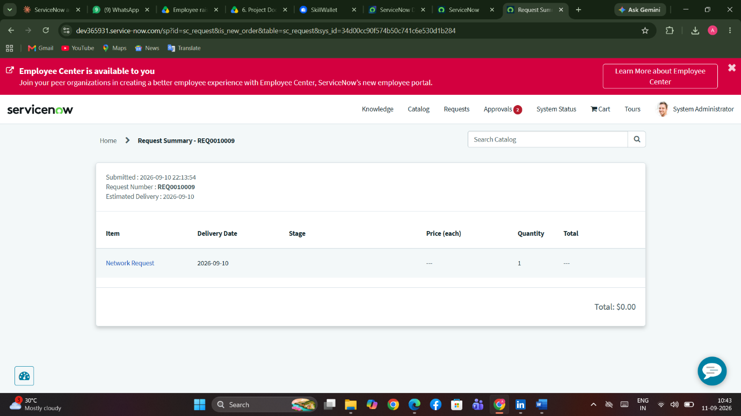

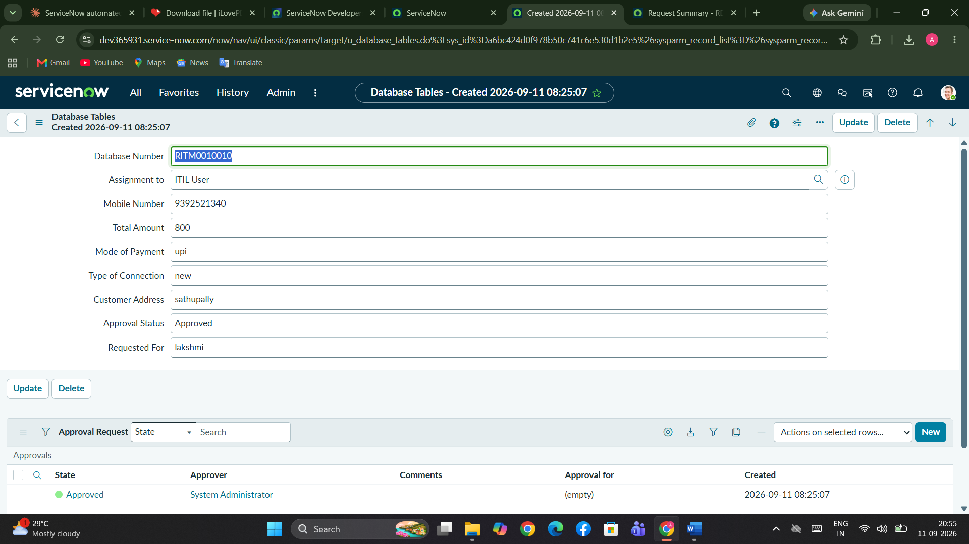
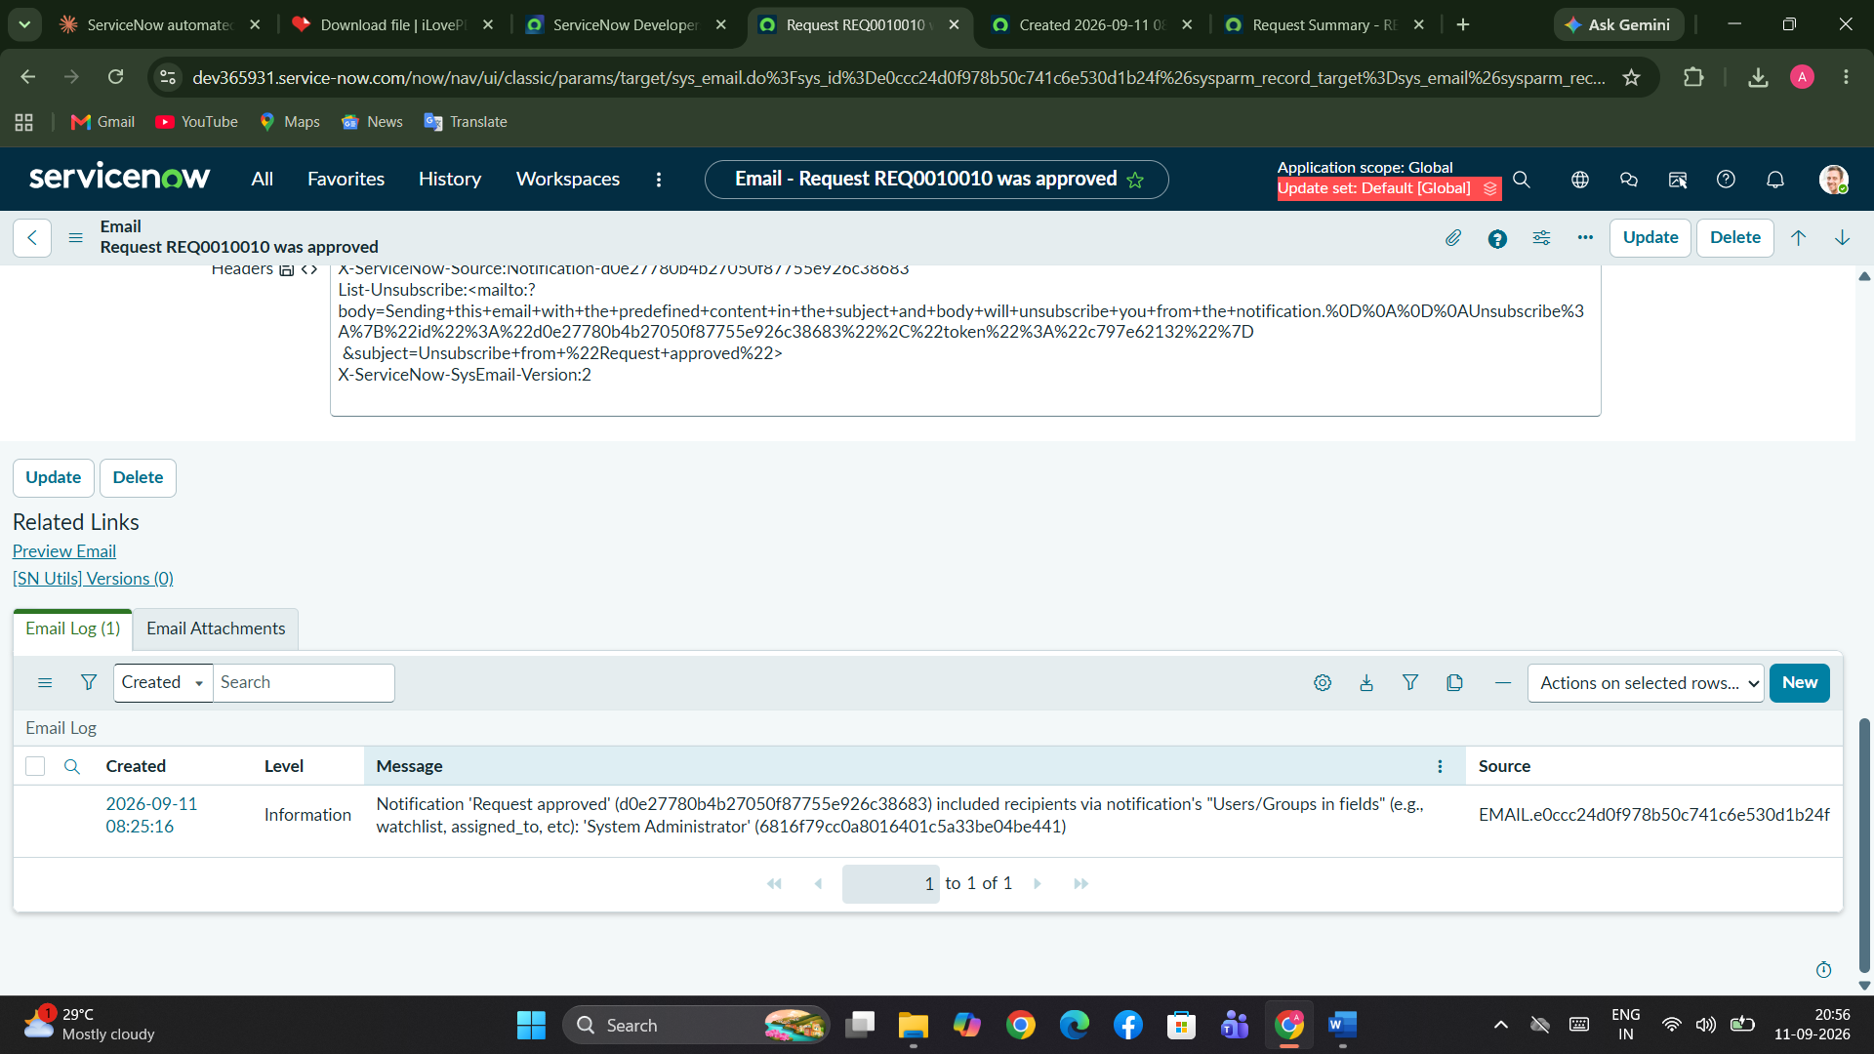
8. Advantages & Disadvantages
Advantages
- Fully declarative build — no custom scripting, easy to maintain and hand off
- Single guided form replaces scattered email/call-based requests
- Real-time visibility into approval and fulfilment status for requesters
- Role-based access control protects request data by default
- Reusable pattern that can extend to other ServiceNow request types
Disadvantages
- Limited to ServiceNow's native capabilities — complex custom logic would require scripting
- No automatic network provisioning — fulfilment is still performed manually by the IT team
- Single-approver routing in the current version; multi-level approval chains are not yet configured
9. Conclusion
Automated Network Request Management successfully automates request intake, routing, and fulfilment for network services on ServiceNow. Through a guided Service Catalog form, role-based approvals, and automated notifications, it delivers transparency and efficiency across the request lifecycle while remaining simple to maintain and extend, validated through comprehensive UAT with all test cases passing.
10. Future Scope
- Auto-provisioning through integrations with network tools such as Cisco DNA Center or Ansible
- Orchestration flows using ServiceNow Integration Hub
- Reporting dashboards for request volume and fulfilment metrics
- Multi-level approval chains for higher-value or higher-risk requests
- Expansion to other IT services (hardware, software, access requests) using the same pattern
11. Appendix
Source Code: Not applicable in the traditional sense — the solution is a ServiceNow configuration package. The complete build is captured in the project's Update Set (sys_remote_update_set – Automated Network Request Management), which contains the catalog item, variables, variable set, UI Policy, custom table, role, ACLs, and Flow Designer flow.
Dataset Link: Not applicable — this project does not use an external dataset.

